KAZAKHSTAN IN THE SYSTEM OF GEOPOLITICAL AND REGIONAL RELATIONS OF THE EU AND THE PRC
Gulnara BIRIMKULOVA, Aigerim IBRAYEVA, Yermek DUISENKOZHA, Erkin BAYDAROV

DOI: https://doi.org/10.37178/ca-c.20.3.02

Gulnara Birimkulova, Ph.D. Candidate, Department of Regional Studies, Faculty of International Relations, L.N. Gumilev Eurasian National University (Nur-Sultan, Kazakhstan)
Aigerim Ibrayeva, Ph.D., Associate Professor, Higher School of Social Studies and Humanities of the Astana International University (Nur-Sultan, Kazakhstan)
Yermek Duisenkozh, Senior Lecturer, M.A., Department of Oriental Studies, Faculty of International Relations, L.N. Gumilev Eurasian National University (Nur-Sultan, Kazakhstan)
Erkin Baydarov, Ph.D. (Philos.), Associate Professor, Lead Researcher, R. Suleimenov Institute of Oriental Studies (Almaty, Kazakhstan)

ABSTRACT
The European Union (EU) and the People’s Republic of China (PRC) are powerful trade and economic partners in the global market. As of 2019, the EU was the PRC’s largest trading partner (the second-largest was ASEAN, and the United States ranked only third), and for the EU, PRC is the number one partner. In China, there are special forms of partnership with other entities of international relations associated with the new foreign policy strategy. The common interests of the EU and China in the use of the Caspian region’s energy resources lead to mutually beneficial cooperation between the two actors. The Republic of Kazakhstan (RK) is the main link in cooperation between these actors in the Caspian region.
Currently, transcontinental communication projects are underway: The Western Europe-Western China highway that spans 8,700 km and traverses Kazakhstan, and railway and pipeline networks. The Kazakhstan initiative to create an integral Eurasian pipeline system in the Caspian region is promising.
The authors examine the role and place of the Caspian region in modern geopolitics, the regional strategic interests of the EU and the PRC, and emphasize the nature of the EU and PRC’s energy policy in the Caspian region. The potential of their economic interaction is analyzed. The purpose of this scientific study is to compare the geopolitical interests of the EU and the PRC in the Caspian region. The novelty of the study is determined by the fact that developmental trends of the geopolitical situation in the Caspian region have been analyzed within the framework of EU—PRC cooperation.
Today, the Caspian region is a key space in Eurasia, where the geopolitical interests of the most important actors in modern international relations collide. The establishment of geopolitical control and access to Caspian energy resources is an instrument for ensuring the national security of the EU and China.
Keywords: European Union, China, Kazakhstan, cooperation, Caspian region, geopolitics.

Introduction
Since 1991, the geopolitical setting around the Caspian region has undergone dramatic changes. It was seriously influenced by repeated attempts to determine the international legal status of the Caspian Sea on a multilateral basis, a certain militarization of the Caspian states, as well as by environmental problems. In particular, the issue of biodiversity conservation in the unique reservoir was and remains one of the main issues on the agenda.
The key influence on the geopolitical situation is exerted by the region’s hydrocarbon resource issues. In the 21st century, the latter have become priorities on the political debate agenda both in the region itself and in adjacent and even very remote regions, such as the European Union and the People’s Republic of China. The Republic of Kazakhstan, which has a large share of proven oil reserves (3.6 billion tons),¹ has its own stance in regard to the regional energy resource issues. One of the priorities of Kazakhstan’s foreign policy is to strengthen its positions in the Caspian region.
Particular attention is heeded to the review and analysis of the processes of attracting foreign investment that involve the Kazakhstani sector of the Caspian Sea and adjacent territories (hereinafter referred to as the Kazakhstani sector of the Caspian): the main trends in investment inflow and the investments’ sectoral and geographical structure are discussed. The article clarifies the issues that allow to specify the scale of real foreign investment flows and their impact on Kazakhstani economy, the factors that influence this process, the relationship between the country’s advancement in international ratings and the attraction of investments from the EU and China. In addition, trends and features of Kazakhstani investments abroad through state financial institutions are considered.
The competition between external players in the Caspian region manifests in various aspects. At the same time, external players are actively using intraregional contradictions to promote their geopolitical interests in the Caspian region, and Kazakhstan is, in fact, acting as a connecting link, as it tries to promote the development of an appropriate legal and regulatory framework on interstate sites that regulates oil and gas production and allows for a more accurate determination of the legal status of the sea. All of the above does not prevent Kazakhstan from actively attracting foreign investments from the EU and China to the extraction of energy resources. The following companies have been present in Kazakhstani fields since 1997: that year, CNPC bought Aktobemunaygas (Zhanazhol, Kenkiyak). In 2001, CNPC acquired 50% of Buzachi Operating Ltd. In 2006, it bought 100% of PetroKazakhstan, and the Chinese CITIC Group bought 50% of the shares of Karazhanbasmunay. In 2009, CNPC bought 50% of Mangistaumunaygas, in 2013 CNPC bought out the share owned by ConoccoPhillips (16.8%) in Kashagan from KazMunayGas. EU oil companies are widely represented in Kazakhstan—Eni (Karashyganak—25%, Kashagan—16.81%), ExxonMobil (Tengiz—25%, Kashagan—16.81%), Royal Dutch Shell (Kashagan—16.81%, Arman—50%), British Gas (Karashyganak—20%), Repsol YDF (Zhambay-Yuzhny—25%).² Each of the external players present in the region proceeds from their own geopolitical interests, even when regulating the legal status of the region. The same tendency manifests itself in determining regional energy resource reserves, where the EU and the PRC use their estimates (that sharply differ from each other) as an instrument of pressure on third-party competitors, such as the Russian Federation, Japan, and the United States.
Currently, the Caspian region is a powerful tool for Kazakhstan that helps attract foreign investment, and provides the country with the status of an “oil power” and a spot in the geopolitical power balance. This proves that “the geography of Kazakhstan’s foreign trade has developed under the influence of global trends in the growth of demand for energy resources, as well as the peculiarities of the country’s location in the center of the Eurasian continent. The latter has shaped the two key directions of Kazakhstan’s export-import policy, namely, Europe and Asia. By choosing the direction of foreign trade, Kazakhstan can influence the change in the geopolitical and geo-economic situation in the region.”³
At the same time, a number of extra-regional investor countries began to actively use the issue of the Caspian region’s legal status and manipulate the assessment of its hydrocarbon potential to secure their rights to the Caspian fields. The competition between countries for securing control over Caspian energy resources is exacerbated by OPEC’s restrictions on oil production.
Due to the above, the EU and the PRC began to establish competitive pipeline routes in the Caspian region within the Western Europe-Western China transport system. At the same time, Kazakhstan, located in the center of the Eurasian continent, benefits from the establishment and development of this transport infrastructure. Its main trade partners, the European Union and China, are also interested in the development of pipelines.

Research Methods
The study uses the method of comparative and statistical analysis in order to comprehensively assess the role of the EU and the PRC in the shaping of interaction in the region under consideration. The article used a systemic analysis of various aspects of the regional geopolitics of the EU and China as external partners and the Republic of Kazakhstan as a key regional country. The systemic analysis method was utilized for the general analysis of the geopolitical situation in the Caspian region and the impact of key extra-regional actors, namely, the EU and the PRC, on its development. A comparative analysis was used to study the nature and compare the cooperation between the EU, China and the Republic of Kazakhstan in the Caspian region.
The spatial modeling method is used due to the fact that trade relations with partners are based on the supply of goods to various regions. The BRI project has become one of the means of cooperation. In this regard, the spatial distribution of interstate project participants revealed the possibility of risk stratification. The spatial method was used to visualize and map the illustrations.

EU Strategy in the Caspian Region
The Caspian oil-producing region comprises the Caspian Sea and adjacent countries with oil and gas-producing areas. Economic stabilization and political stability allow the regional states to actively develop their deposits. The government of Kazakhstan has tasked itself with becoming one of the fifty most economically developed countries. To solve this task, Kazakhstan has begun to successfully develop the regional oil and gas fields.
Figure 1
Political and Administrative Map of the Caspian Region
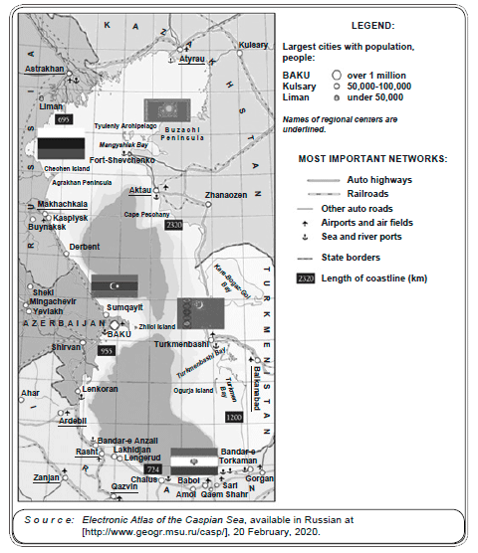
Today, the Caspian region, which is rich in oil and gas reserves, is one of the key nodes of modern energy policy, and Kazakhstan is the leader in terms of production and proven oil reserves. This fact plays a dominant role in shaping the structure of Kazakhstan’s economy and foreign trade. The share of imports from regional countries in Kazakhstan’s trade turnover is significant.⁴ Now the Caspian region is being developed by five countries: the Russian Federation, Kazakhstan, Iran, Azerbaijan and Turkmenistan (see Fig. 1), but Kazakhstan is the leader in terms of production and proven oil reserves. The Concept of Foreign Policy of the Republic of Kazakhstan for 2020-2030 was adopted on 9 March, 2020. It outlines the benchmarks of Kazakhstan's foreign policy and tasks related to the country’s place on the global stage.
The Kazakh side is actively involved in the integration processes in the Caspian region. “Kazakhstan can influence the solution of urgent problems of regional economic integration, primarily because, first of all, it relies on the Eurasian integration strategy; secondly, it is a member of all regional alliances concerned with the stability of the Caspian economic system—the CIS, the Customs Union of Belarus, Kazakhstan and Russia, the EurAsEC, as well as the ECO and the SCO; thirdly, it can become an intermediary between the EU, the countries of Central Asia, China and other regional states.”⁵
Kazakhstan is currently an active participant in the global energy market, which determines both the export and the overall economic policy of the state over the past decade. The energy intensity of the economy is a particular indicator of the natural resource intensity. This is a key indicator characterizing the sustainability of development of both the energy sector and the country as a whole (see Fig. 2).
Figure 2
The Dynamics of the Energy Intensity of GDP in the Caspian Region in the Republic of Kazakhstan in 2011-2018
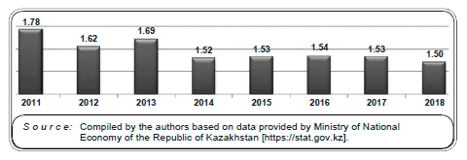
A joint meeting of the chambers of the Parliament of the Republic of Kazakhstan took place on 15 June, 2019, during which a report on the economic process in the Kazakhstani sector of the Caspian Sea was adopted. Total economic growth in this region of the Republic of Kazakhstan in 2019 equaled 4%. In addition to external factors, stable GDP growth was facilitated by the growth of industry (oil production) by 7.1%. In late 2019, agreements were reached on the implementation of 42 new projects with major investors, including those from China and the EU countries. In total, 54 projects totaling $3.9 billion will be completed in 2020. Work has begun on 63 joint projects with the EU and the PRC.⁶ Thus, the transport industry and the oil and gas production infrastructure of the Kazakhstani sector of the Caspian contribute significantly to the development of the country.
A very significant part of investments from the EU and China goes to Kazakhstan specifically for the Caspian projects. This factor determines the mining importance of the Caspian region for the further economic development of the Republic of Kazakhstan. At this time, oil reserves in the region amount to 5.1 billion tons, gas reserves—to 8 trillion cu m. From 1991 to 2018, the share of proven oil reserves in the region relative to global reserves increased from 2.6% to 3.3%, and proven gas reserves—to about 5%. Between 1991 and 2019, oil production increased from 26.6 to 90.3 million tons per year, and gas production is also growing—from 1991 to 2018 it increased from 23.7 to 77.1 billion cu m per year.⁷
At present, as the positions of the EU and China in the global economy strengthen, the geopolitical situation around the Caspian region and its resources has begun to undergo significant changes. The EU is implementing the Greater Europe strategy and, having determined the forms of regional cooperation with the countries it directly borders, it adopted a strategy for interaction with the countries of Central Asia, including Kazakhstan, on 31 May, 2007. It was finally formulated at the end of 2007, when the European Energy Policy was adopted, but it still being refined and improved with regard to new geopolitical and economic realities.
The relations between Kazakhstan, the European Union and China can be fully characterized by J. Kennedy’s phrase: “Geography has made us neighbors. History has made us friends. Economics has made us partners. And necessity has made us allies.”⁸ If the economy has made these countries partners, then the need to strengthen security amid new threats has made them allies. The main spheres of interest of the European Union and China in Kazakhstan are trade and investment, energy, regional integration, transport and transit, water resource management.
Since the beginning of the 21st century, the EU has become Kazakhstan’s main trade and important investment partner. Today, the trade turnover between the EU and RK amounts to $30 billion. The deepening of the EU-RK energy cooperation is of great importance. The first President of the Republic of Kazakhstan Nursultan Nazarbayev said during his visit to Brussels: “Our country is the third largest non-OPEC supplier of energy resources to Europe. The share of Kazakhstani oil is very high in certain EU states. For example, in Rumania it equals 30%, in Austria—25%, in Switzerland RK is in the second place. Kazakhstan provides up to 20% of the total volume of energy imports to the countries of the United Europe.”⁹ Nowadays, Kazakhstan exports $10 billion worth of oil to the EU.
Kazakhstan, just as its partners, still needs to partner with China in the development of hydrocarbon deposits. So, back in 2009, the domestic consumption of oil and natural gas in the European Union amounted to 670.8 million tons and 459.9 billion cu m, respectively, while production equaled to 98.7 million tons and 171.2 billion cu m¹⁰ The influx of foreign investments to Kazakhstan is traditionally regarded as one of the most important factors in the development of the economy and is an example of policy efficiency in the international economic cooperation sphere. At half year-end 2018, the volume of accumulated foreign investments amounted to $225 billion. In terms of the volume of attracted foreign investment, Kazakhstan is among the leaders not only in the post-Soviet space, but also in broader international comparisons. Thus, the amount of accumulated foreign direct investment (FDI) at the end of 2019 equaled 105% of GDP (GDP—$162.9 billion, FDI stock—$170.4 billion). This figure is significantly higher than the global average, the average for the OECD and the EU, and the indicators of neighboring countries such as the PRC and Russia (see Fig. 3¹¹).
Figure 3
Volume of Accumulated Foreign Direct Investments against GDP
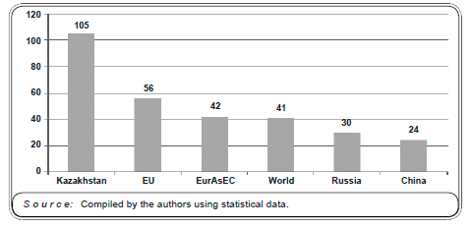
Attracting foreign investment has always been characteristic of the Kazakhstani economic model. The inflow of investments into Kazakhstan in the first years of the country’s independence was rather large-scale. It became the main factor in the intensive development of large oil and gas fields, thereby laying the foundation for dynamic economic development. Kazakhstan has become one of the leaders in attracting foreign investment not only in the post-Soviet space, but also among all the developing economies of the world, which made it possible to raise the status of the national economy due to the extensive participation of large foreign companies in the country’s economy, recognition of the market nature of its economy, obtaining high credit ratings, being promoted in a number of international indices and rankings.
The geography of foreign investments attracted to Kazakhstan is diverse: neighboring Russia is one of the investors along with the largest economies of the world, such as the EU and China; offshore territories and geographically remote states are among the leaders in terms of accumulated investments, which testifies to the extensive international interest in the country's economy (Fig. 4¹²).
Figure 4
Countries that Invest in Kazakhstan’s Economy
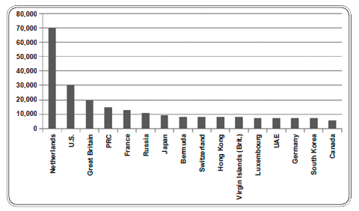
Meanwhile, foreign investments in Kazakhstan are distinguished by a very high level of concentration by donor country (see Table 1 and Fig. 5): the top five investment partners account for 70% of the total investments. According to this indicator, the EU is the undisputed leader. Half of the total foreign investment in Kazakhstan falls on five EU countries: The Netherlands, Great Britain, France, Luxembourg, and Germany. According to the National Bank of the Republic of Kazakhstan, the total inflow of FDI from 28 EU countries in 2018 amounted to $11.6 billion. By the end of 2013, the volume of investments in fixed assets amounted to $30 billion, which corresponds to 47.9% of their total volume. The share of EU countries in the volume of accumulated foreign investments of all types at the end of 2018 amounted to 51.9%; for foreign direct investment this figure equaled 55.7%. Also, the EU countries account for over 72% of the volume of direct foreign investments of Kazakhstan itself, which confirms the priority of the European vector in Kazakhstan’s international investment activity.
European funds are invested in numerous projects, but most of them invest in large projects associated with the development of hydrocarbon deposits and in oil companies in Kazakhstan. For instance, most of the share capital of the second largest Kazakh company, Karachaganak Petroleum Operating (KPO), belongs to the Italian Eni and the Dutch-British Royal Dutch Shell (29.25% each, respectively).
Table 1
Cumulative Inflow of Direct Investments from the EU to Kazakhstan’s Oil Sector, 2005-2018, $m
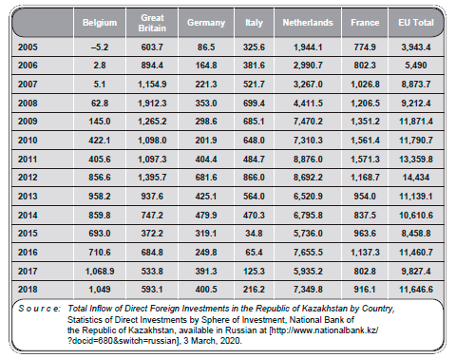
Figure 5
Dynamics of Total Inflow of Direct Investments from the EU to Kazakhstan’s Oil Sector, 2005-2018, $m
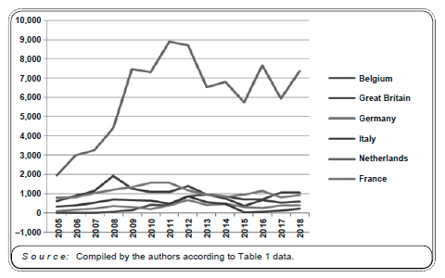
The Russian Lukoil also participates in this company’s share capital with 13.5% of shares, which indicates the scale of KPO activities. Its total investments in the development of the Karachaganak field amounted to more than $20 billion.¹³ European business is also widely involved in the development of other oil fields in the Kazakh sector of Kashagan and the Northern Caspian. The capital of North Caspian Operating Company (NCOC) comprises such large oil companies as Eni, Total, Shell, each of which owns 16.8% of shares. Thus, the European business accounts for the greater part of this megaproject (50.4%). The consortium also includes oil companies from the United States (ExxonMobil), China (CNPC), Japan (Inpex), as well as the Kazakh national oil company KazMunayGas.¹⁴ Specifically, this latter participates in the consortium through its subsidiary company Kashagan B.V., registered in the Netherlands. Therefore, its investments are officially carried out as investments from the EU.
However, the actual participation of European business in large projects of the last decade was significant despite the fact that some of the investments from the EU, such as the aforementioned block of shares owned by Kashagan B.V., are only nominally European, but are, in fact, of Kazakhstani or other non-European origin. This participation is reflected not only in the macroeconomic indicators of the investment flow, but also in specific large-scale projects, including socially significant projects.
Major projects in Kazakhstan’s raw materials sector, including two large projects with the participation of European and Russian businesses, are being implemented under production sharing agreements. These agreements often stipulate the social obligations of the consortia engaged in the development of deposits, which in most cases significantly contributes to the development of the regions where they operate. In general, such agreements will positively impact social progress in three main areas: labor market development through the creation of jobs and staff enhancement, including training in progressive foreign industry technologies; “social responsibility” programs, in which international companies assist in the development of various industries in the regions of their operation; provision of orders and contracts to Kazakhstani supplying companies as part of “programs to increase local contribution,” that is, production localization. The activities of two large Kazakhstani energy consortia with predominantly European capital in these three areas contribute significantly to social progress, especially at the regional level. In particular, KPO (Karachaganak Petroleum Operating) was one of the first in Kazakhstan to start implementing a program to increase Kazakhstani contribution back in 2001. Since then, about 3,800 local suppliers have been registered in the database.
In recent years, the share of Kazakhstani business in the total volume of contracts and purchases by KPO has amounted to 47-50% (in 2015, it was equal to 48.8%, or $581 million).¹⁵ KPO, like other large subsoil users, continues to develop programs to increase Kazakhstani contribution within the framework of the Aktau Declaration. In 2012, this Declaration of Joint Action was signed by three large oil and gas operators in Kazakhstan with the aim of uniting separate programs of companies, investors and government agencies involved in integrating national industries into a single system. In 2015, the participants of this initiative—Tengizchevroil, North Caspian Operating Company, KPO and AO National Company KazMunayGas—continued to work together to settle on technical requirements for a unified supplier database. This database should become the main portal for local suppliers and should meet the needs of all participants.
Another important area of ​​KPO activity that has a direct social effect is attraction of Kazakhstani personnel and increasing employment. The company has observed a positive trend in both the total number of employees and the number of Kazakhstani employees. In 2012-2015, the number of local company employees increased from 3,769 to 4,086 people (by 8.4%). In the West Kazakhstan region, the number of company employees in 2015 amounted to 1.3% of the total employed population, 14.2% of the number of employed in industry, 61% of the number of employees in the oil industry.¹⁶
Thus, the volume of funds invested by just two large Kazakhstani oil and gas projects in Kazakhstan with the domination of European capital in social and infrastructure projects amounted to $900 million. Other programs that promoted social development in the areas of operation were also implemented. In these projects, the operating companies acted as the leading employers in the region, and created a significant demand for goods and services of Kazakhstani suppliers, contributing to the growth of the regional and national economy, expanding the tax base, and increasing employment rates and income of the population.¹⁷
Kazakhstan’s cooperation with European countries was not devoid of certain shortcomings; along with the success in attracting large international companies, some companies that developed oil and gas fields have left, and there was capital outflow from the Kazakh market. As the economic system in the oil and gas sphere matures and strengthens, Kazakhstan will invest in national companies. Thus, KazMunayGas has been consistently included among the operators and beneficiaries of large fields, which were developed by European consortia early on. In this manner, the development of the Kashagan field was started by OKIOC (Offshore Kazakhstan International Operating Company), a consortium of Western oil companies established in 1998. The consortium includes mainly European companies, i.e., Agip (with a share of 14.29%), British Gas (14.29%), Exxon Mobil (14.29%), Shell (14.29%), TotalFinaElf (14.29%), BP Amoco (9.5%), Inpex (7.14), Philips Petroleum (7.14%), Statoil (4.8%).¹⁸
According to Western experts, raw materials from the Caspian region may be of great importance for Europe as an alternative to Arab oil and a source of compensation for the decline in production in the North Sea fields.¹⁹ According to some reports, only Kazakhstan, Azerbaijan and Turkmenistan have oil reserves that exceed 100 billion barrels, which makes the Caspian region the third largest oil reservoir in the world after the Persian Gulf and Siberia.²⁰
During the 6th KAZENERGY Eurasian Forum, EU Commissioner for Energy Günther Oettinger said on the official website of the Prime Minister of Kazakhstan: “For the European Union, the [Trans-Caspian Gas Pipeline] will be a very important step in the development of the Southern Corridor. Not everyone knows that the European Union was the first to offer to conclude an international treaty in support of the infrastructure project. We will support Kazakhstan’s participation in the Southern Corridor.”²¹ At the same time, it can be noted that the new gas pipeline will provide new opportunities for the development of export supplies from the eastern coast of the Caspian Sea.

Main Vectors of the PRC’s Geopolitics in the Kazakhstani Sector of the Caspian Sea
The relationship between Kazakhstan and China is mainly based on economic interests. Chinese companies are involved in various sectors of Kazakhstan’s economy, especially in the oil and gas industry, since energy is of strategic importance to both countries. Currently, Kazakhstan is China’s second-largest trade partner among the CIS countries after Russia. Since last year, the PRC has become Kazakhstan’s number one trade partner. According to statistics provided by the Chinese side, trade between the two countries in 2010 amounted to $20.31 billion (an increase of 45.3%) and exceeded the pre-crisis level. China also accounts for the largest share of Kazakhstan’s export-import oil trade. The volume of Chinese investments in the oil and gas industry in Kazakhstan amounted to $15 billion.²²
Cooperation between Kazakhstan and the PRC in the investment sphere is traditionally viewed in the context of attracting Chinese investments to Kazakhstan, but Kazakhstan also invests in the PRC. According to the National Bank of the Republic of Kazakhstan, as of January 1, 2019, all types of accumulated investments from Kazakhstan to the PRC totaled $3,916 million. Chinese investments in Kazakhstan amounted to $15,212 million. Thus, the net position of the PRC in mutual investment amounted to $10,762 million.²³
In addition, in the context of the implementation of an international oil project, special attention needs to be heeded to Chinese investments in Kazakhstan and the ways in which the implementation of this project influenced the volume of investment flows from the PRC. An analysis of these flows, both in absolute terms and in their share and dynamics of accumulated investment volume allows to conclude that China’s role in Kazakhstan’s investment platform is decreasing. The total inflow of direct investments from China to Kazakhstan has been declining throughout most of the implementation period of the BRI project, which also led to a decrease in the share of Chinese investments in the total amount of accumulated FDI and other investments in Kazakhstan.
In the year when the Silk Road Economic Belt project was announced, the PRC's share in the total FDI inflow to Kazakhstan was 9.3%, and in 2018 it decreased to 6.1%. In recent years, the share of China in the total volume of accumulated foreign investment of all types has decreased from 9.6% in 2013 to 6.9% in 2018 (see Table 2 and Fig. 6).
Table 2
Dynamics and Role of PRC’s Investments in Kazakhstan
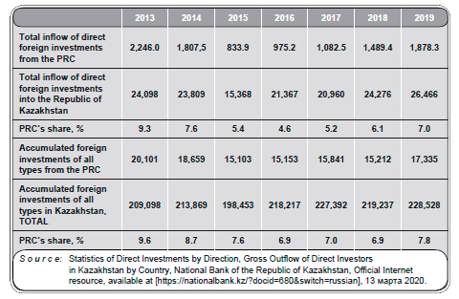
Figure 6
Dynamics and Role of PRC’s Investments in Kazakhstan
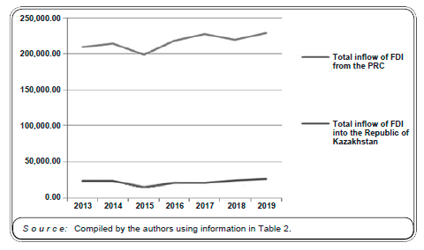
The oil industry is the main sector of Kazakhstan’s economy. The oil-rich Kazakhstani sector of the Caspian is an important source of raw materials not only for Chinese oil companies, but also for companies from many other countries. The basis for bilateral relations in the field of oil production between Kazakhstan and China was laid by the intergovernmental agreement signed in September 1997 on cooperation in the field of oil and gas and the agreements between the Ministry of Energy and Natural Resources of the Republic of Kazakhstan and the Chinese National Oil and Gas Corporation on the oil pipeline, river project and the Kazakh-Iranian oil pipeline. These documents were of strategic importance for both states and created a solid foundation for long-term mutually beneficial cooperation.
Subsequently, Chinese companies acquired shares in a number of oil-producing enterprises in Kazakhstan. Most of the oil fields in the country are developed mainly by two large Chinese companies: CNPC (China National Petroleum Corporation) and CITIC (China International Trade and Investment Company). After signing a bilateral agreement in 1997, CNPC initially acquired Aktobemunaygas (Zhanazhol, Kenkiyak). In 1998, when the Chinese oil company took over the Aktobe Oil Company, the annual oil production was only 2 million tons. Ten years later, thanks to Chinese technology, investment and management system, the annual production increased 2.5 times. In 2001, CNPC acquired a 50% stake in the North Buzachi, a gas and oil field in the Mangistau region of Kazakhstan, on the Buzachi Peninsula. The field is being developed by Buzachi Operating Ltd, a joint venture owned in equal shares by Nelson Petroleum Buzachi BV and Chinese oil company CNPC). In 2006, CNPC acquired Petro-Kazakhstan, and CITIC bought a 50% stake in Karazhanbasmunay. In 2009, CNPC acquired a 50% stake in Mangistaumunaygas. New technologies for exploration, drilling, storage and processing of oil and gas arrived in Kazakhstan along with Chinese oil companies. The introduction of CNPC technology allowed to develop the Kenkiyak oil field with reserves of 28 million tons in a short time, despite its notoriety for its difficult geological conditions. Currently, 2 million tons of oil are produced here annually. The Atasu-Alashankou, Kenkiyak-Kumkol, Kazakhstan-China and Beineu-Bozoi-Shymkent pipelines²⁴ were built to transport the extracted oil to China. The government of the People’s Republic of China participated in financing the construction of oil pipelines that spanned thousands of kilometers traversing Central Kazakhstan towards the north-western Chinese border. These and other pipelines are interconnected, expanding access to oil sources at the bottom of the Caspian Sea. Kazakhstan seeks to control the development of its oil fields by investors from Russia, China and the West, but the global financial crisis has allowed China to increase its influence in Kazakhstan’s oil industry and enter other sectors of the Kazakh economy.
Fig. 7 reflects China’s growing role in Kazakhstan’s energy sector and demonstrates that energy cooperation between the two countries is of strategic importance.
Figure 7
Share of Chinese Companies in the Capital of Kazakhstani Oil Companies (%)
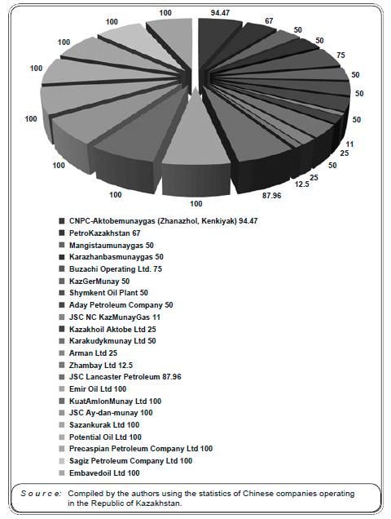

Conclusion
Currently, the priority areas for the EU and the PRC are the strengthening of energy diplomacy in the Caspian region, and more effective participation of the Republic of Kazakhstan in it. One of the key factors in energy diplomacy is the Caspian region, including the Kazakhstani sector of the Caspian. As noted by many, Kazakhstan is a symbol of stability for the EU countries and the PRC, as well as a bridge connecting the West and the East. The interaction between the EU, PRC and RK is growing year to year.
The strategic partnership between Kazakhstan, the EU and China opens up numerous prospects for realizing the interests of each of the parties. At the same time, deeper cooperation scenarios are limited by China’s position on the country’s unconditional sovereignty in decision-making processes based on its own principles. There is an obvious gap between China’s approach, which allows for diversity of norms and common interests as the basis of cooperation, and the European approach, according to which differences of interests can be bridged by reaching an agreement on universal political rules. Hence the second contradiction: the EU is inclined to believe that the emergence of a multipolar world order will lead to effective multilateral cooperation, and that states like China will then abandon the principles of sovereignty and non-interference. At the same time, Beijing is using all the power of its position to uphold these principles in international institutions, such as the U.N. The legal framework for international cooperation is a key source of controversy and an obstacle to reaching an understanding on the basic principles of cooperation.
Despite the ambiguity of interpretations of the place and role of interstate strategic partnership, cooperation between the EU and China is characterized by the following parameters. The EU is China’s largest trading partner, and China is the EU’s second largest trading partner after the United States. In 2018, trade in goods between the EU and China amounted to 518 billion euros, and trade in services reached 78 billion euros. Trade and investment exchange between the EU and China became one of the main sources of wealth, job creation, development and innovation. The partners work together to achieve fast, sustainable and balanced growth, and have a common interest in creating a more stable and secure world to everyone’s benefit.
The EU’s share of total foreign direct investment in China is stable at about 20%. This makes the EU one of the top five FDI donors to China. However, this share could be significantly increased, as it only accounts for 6% of the total EU FDI inflows, and the EU’s share in the total FDI outflows from China remains similarly small. Investment negotiations between the EU and China are aimed at improving access to the investment market and the overall investment climate in China for investors from the EU, and in the reverse direction. Thus, relations between the EU and China demonstrate a powerful development impetus against the background of growing economic interdependence, which is accompanied by a constant deepening of their political dialog with the Republic of Kazakhstan.
The oil sector is the principal component in the economy of the Republic of Kazakhstan, along with the extraction of coal, uranium and other important raw materials.
Over the past two decades, stable and mutually beneficial relations in the energy sector have developed between Kazakhstan, the EU and the PRC. Major European and Chinese energy companies have invested heavily in Kazakhstan’s oil and gas industry. Currently, about 70% of the total volume of exported Kazakhstani oil falls on the EU countries and China, which corresponds to about 6% of the total volume of oil imports by the EU and China. On the other hand, Kazakhstan’s national oil and gas company KazMunayGas controls significant oil refining capacities in the EU and PRC.
In recent years, cooperation between the EU, China and the Republic of Kazakhstan has been successfully developing in trade, economic, energy, non-raw materials, infrastructure and other spheres. The prospects of further development of the mining industry and non-resource sectors of the economy are quite significant. Therefore, Kazakhstan should not limit itself to raw materials, and heed attention to the further development of cooperation with the EU and China in other industries.
With regard to the above, both the foreign and domestic policy of the Republic of Kazakhstan in the energy sphere actually contributes to the rapprochement and interaction of the EU countries and the PRC, while the country itself is a “moderator” in the relations between these countries.

¹ According to the National Bank of the Republic of Kazakhstan: Direct Investments in The Direction of Deposits by Country, State of the Net Position as of 1 February, 2020, Statistics of Direct Investments in the Direction of Deposits, National Bank of the Republic of Kazakhstan, Official Internet resource, available in Russian at [Link], 15 February, 2020. _{Back to text}
² See: “V RK 22 neftianye kompanii s kitaiskim uchastiem,” available at [Link], 15 February, 2020. _{Back to text}
³ See: K.B. Safinov, M.S. Kulmamirova, N.I. Illeritskiy, “Kazakhstan v energeticheskoy integratsii EAES: perspektivy, riski, vozmozhnosti,” available at [Link], 20 February 2020. _{Back to text}
⁴ See: B.K. Sultanov, Tsentralnaia Azia i Kaspiiskiy region: riski, vyzovy, ugrozy, Monograph, KISI under the President of RK, St. Petersburg, Almaty, 2012, 224 pp. _{Back to text}
⁵ See: “Interesy Kazakhstana v Kaspiiskom regione,” available at [Link], 20 February, 2020. _{Back to text}
⁶ Calculated from the National Bank of Kazakhstan: International Investment Position of Kazakhstan: Standard Presentation, 1 October, 2018, International Investment Position, National Bank of the Republic of Kazakhstan, Official Internet resource, available at [Link], 22 February, 2020. _{Back to text}
⁷ See: Gross Domestic Product: Total and Per Capita, Current Prices, Annual; Merchandise: Total Trade and Share, Annual; Foreign Direct Investment: Inward and Outward Flows and Stock, Annual, UNCTADStat Data Center, available at [Link]. _{Back to text}
⁸ See: A. Collins, John F. Kennedy, Oxford University Press, 2012, 213 pp. _{Back to text}
⁹ See: “Kazakhstan-ES: novaia stranitsa otnosheniy. Prezident N. Nazarbayev posetil Bryussel s odnodnevnym rabochim vizitom,” 13 April, 2010, available at [Link], 25 February, 2020. _{Back to text}
¹⁰ Calculated according to UNCTAD: Foreign Direct Investment: Inward and Outward Flows and Stock, Annual, UNCTAD Stat Data Center, available at [Link], 27 February, 2020. _{Back to text}
¹¹ Created according to the Data of: FDI Stocks, OECD website [Link], 2 March, 2020; Main Socio-Economic Indicators of the Republic of Kazakhstan, Agency on Statistics of the Ministry of National Economy of the Republic of Kazakhstan, available at [Link], 2 March, 2020; National Bank of the Republic of Kazakhstan, Official Internet resource, available at [Link], 2 March, 2020. _{Back to text}
¹² See: National Bank of the Republic of Kazakhstan, Official Internet resource, available at [Link], 1 March, 2020. _{Back to text}
¹³ See: Kompanii-partnery. O kompanii Karachaganak Petroleum Operating B.V., available at _{Back to text}
[Link], 9 March, 2020.
¹⁴ Ibidem. _{Back to text}
¹⁵ See: Kazakhstanskoe soderzhanie. Karachaganak Petroleum Operating B.V., available at [Link], 10 March, 2020. _{Back to text}
¹⁶ See: B.K. Sultanov, op. cit. _{Back to text}
¹⁷ See: Severo-Kaspiiskiy proekt. ТОО PSA website [Link], 10 March, 2020. _{Back to text}
¹⁸ See: Karachaganak. ТОО «PSA» [Link], 11 March, 2020. _{Back to text}
¹⁹ See: S. Kushkumbayev, “Vliianie energoresursov na nekotorye aspekty vnutrenney i vneshney politiki Kazakhstana,” Tsentralnaia Azia i Kavkaz, No. 1, 1998, p. 41. _{Back to text}
²⁰ See: New York Times, 17 February, 1998. _{Back to text}
²¹ See: Günther Oettinger’s Speech at the VI KAZENERGY Eurasian Forum, available at [Link], 11 March, 2020. _{Back to text}
²² See: K. Yu, “Energy Cooperation in the Belt and Road Initiative: EU Experience of the Trans-European Networks for Energy,” Asia Europe Journal, No. 16 (12), 2018, pp. 251-265. _{Back to text}
²³ See: International Investment Position of Kazakhstan by Country (HIP). International Investment Position, National Bank of the Republic of Kazakhstan, Official Internet resource, available at [Link], 15 March, 2020. _{Back to text}
²⁴ See: Direct Investment Statistics by Direct Investment Direction / Gross Outflow of Direct Kazakhstani Investors by Countries Abroad, National Bank of the Republic of Kazakhstan, Official Internet resource, available at [Link], 13 March, 2020. _{Back to text}

